REFLECTION FOR SEA SUNDAY 2019
READINGS:
- AMOS 7.7 – 17 Vision of the Plumb Line, Amos and Amaziah
- PS 83
- COLOSSIANS 1.1 -14
- LUKE 10. 25 – 37
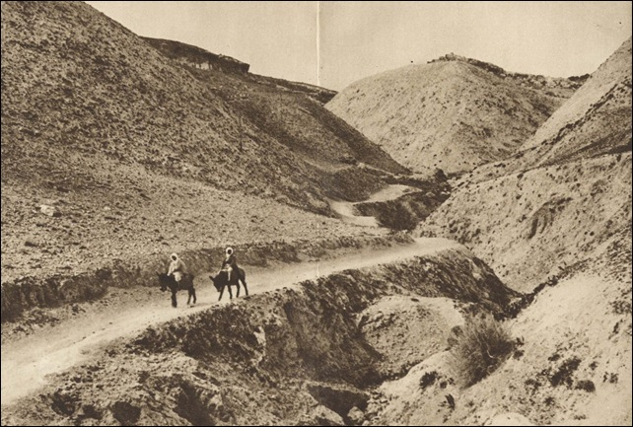
The old road from Jerusalem to Jericho.
Sea Sunday 2019.
With numerous scriptural stories based on the sea, from catching fish and walking on water to being swallowed by whales; one may initially wonder why the Australian Church allocated the land-based Gospel story of the Good Samaritan for Sea Sunday.
However, it doesn’t take much effort to see that whether in a deserted arid location or on the high seas, the readings from Amos, Colossians 1, and Luke, give ample links between the prophet Amos and prophetic ministry, Paul’s prayer that Christ’s gospel is bearing fruit and growing throughout the world, and Luke’s caring Samaritan and our caring volunteers, a vulnerable traveler and our vulnerable seafarers.
The Mission to Seafarers ministers in over 200 ports in 50 countries, caring for the world’s 1.5 million seafarers through our network of chaplains, staff and volunteers. Our centres provide a home away from home where seafarers can relax, use internet to contact loved ones and purchase necessary personal items; while our ship visitors offer on board practical, emotional and spiritual support to crew.
We are asked to proclaim the Gospel of Jesus Christ through witness and service. The example by Jesus of the Good Samaritan is one that our Mission asks Christians to reflect upon this year. Our centres have stories of seafarers who have been left battered and bruised in body mind or spirit by those for whom they work, from others on board ship, in foreign ports, and even sometimes by families who rely on their incomes. We are commanded to go further than normal words of sympathy for the broken and expected to help unconditionally until the broken body is restored, and the way made easier for those who will follow down the same track. In that way we try to follow the original scripture verse from Revelation 14.6: “Then I saw another angel, flying high in the sky, sent to proclaim the everlasting good news to in habitants of the earth, to every nation, race, language and people”.
We are asked to pray and offer appropriate ministries of worship, word and sacraments to nurture and support seafarers while in port and at sea. Most crews visiting our centres have a faith background in one religion or another, the majority being Catholic Christians. Life at sea brings unimaginable stresses – from bullying and threats, from seasickness and injury, loneliness and depression…yet all the while, they enter our Mission centres with smiling faces, seeking to forget the work, ignore the hours of broken sleep and the distance from loved ones. They need assurance that they are important, loved and cherished. They need our prayers, our blessing and the ministrations of a priest for the Church’s Sacraments on board ships where suicides, murder or other events have occurred to haunt their lives. We work with the International Christian Maritime Association to spread Gods love through scriptural teaching among the world’s seafarers so that they may have ‘full knowledge of his will through all wisdom and spiritual understanding’ as we read in Colossians 1: 5.
We are asked to promote justice and welfare within the maritime industry and become involved in our industrial settings. We need to better prepare seafarers for their work, to better inform governments how best to cater for international seafarers. We need to monitor how Labour Conventions are working in Australia and worldwide…How we can prevent situations where young seafarers are treated as virtual slaves by some shipping agencies in third world countries; or enquiring if crews are being given access to proper shore leave and welfare agencies; or being repatriated safely home at end of their nine month contracts away from families! The Mission often walk a tightrope between union and owners, agents and crews; but we cannot forget our core statement that we are called to act, like the plumb-line in Amos’ vision. “He was standing beside a wall with a plumb line in his hand.” Amos 7: 1.
And then, we are asked to promote a spiritual vision of shared dignity. We are asked to reach out to the stranger, no matter their background, ethnicity or creed. We believe our Mission is like the parable of the sower, some spreading the seed of Good News whenever crew enter the Mission centres. Some of our ministries are likened to the gardener who maintain the field or the vine, pruning, watering and fertilizing it as it grows from seed. Some are like the reapers, who gather the crop, fully grown and mature. Our ship visitors take Bibles and other material for the crew when they board the ships and meet all stages of Christian growth. We follow the Franciscan example of seeking the face in Jesus in everyone we meet…hoping that they in turn will see the face of Jesus in the ship visitor. We believe that we meet everyone in their own special space and place; that when we enter their ship, we are visiting their workplace and their home. Our Mission call is to be ready to welcome the Stranger as we see in Matthew 25: 31 -40 or from Luke 10: 36 when “Jesus asked, Which of these three, do you think, made himself a neighbour to the man who fell into the hands of robbers?” The teacher of the law answered, “The one who had mercy on him.” And Jesus said, “Go then and do the same.”
Finally, we are asked to speak prophetically without being triumphalist. In this we are asked to take a lead in the ministry for seafarers around the world. We are to walk humbly with our God as we read in Micah 6:8, in the knowledge that through faith in Christ, we are called to speak out for this group of men and women who are often called the least, the lost and the last; an ‘invisible congregation’. Over our past 163 years the Mission has seen unbelievable changes in shipping and yet has found an ability to adapt with it – but the focus, its core has never wavered…to bring Christ in Word and Sacrament to those who go down to the sea in ships.
So, the over-riding theme for Sea Sunday 2019 is the call to act, to go beyond a simple act of charity; and move on to unconditional love for those in need in our community. The Mission to Seafarers provides every possible help in the first instance, but we are to form a framework locally, nationally and internationally to make the future road a little easier, a little simpler, for those who must leave their families to work upon the oceans of the world.
We pray for all those who live and work upon the oceans of the world, for all seafaring ministries, and those who are called to serve in them sharing the love of Christ. Amen.

